# CS 255 System Design Document Template

This template lays out all the different sections that you need to complete for Project Two. Each section has guidance to prompt your thinking. You will need to continually reference the interview transcript as you work to make sure that you are addressing your client’s needs. There is no required length for the final document. Instead the goal is to complete each section based on what your client’s needs are. Remove this note when you are finished, and replace all bracketed text with the relevant information.

## UML Diagrams

### UML Use Case Diagram

**

### UML Activity Diagrams

Instructor Lessons

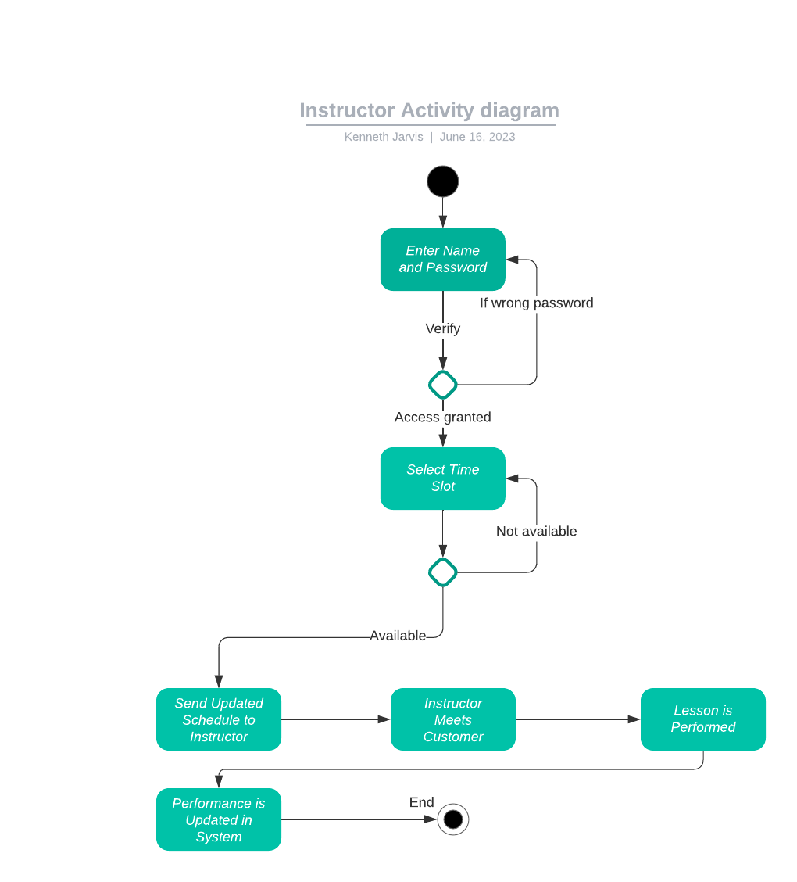

Purchasing a Package

### UML Sequence Diagram

Instructor Sequence Diagram

### UML Class Diagram

Instructor UML Class Diagram

## Technical Requirements

Based on the diagrams I provided, the technical requirements would be a modern computer with an x64 processor and at least 4 GB of RAM. It will use Ubuntu Server for the OS and be able to access the UI from another computer’s web browser. The customer’s and admin’s computer will need an OS that can run a web browser, such as Windows, Mac, Android, or Linux, with a GUI. Every customer will need to make an account with a username and password and supply an email address for password resets. An administrator will be needed for updates, and modifying accounts as necessary. The administrator will need to monitor the system to ensure it can handle web traffic properly and upgrade when necessary.